Batch: B2 Roll No.: 16010121200

Experiment No. 01

Grade: AA / AB / BB / BC / CC / CD /DD

Signature of the Staff In-charge with date

Title: Activation functions.
___________________________________________________________________________________
Objective: To implement activation functions of Neural Network: Identity, Binary Threshold, Sigmoidal, Tangent, Ramp, Relu, Soft max
___________________________________________________________________________________
Expected Outcome of Experiment:
CO-1: Identify and describe soft computing techniques and their roles ____________________________________________________________________________________
Books/ Journals/ Websites referred:
- J.S.R.Jang, C.T.Sun and E.Mizutani, “Neuro-Fuzzy and Soft Computing”, PHI, 2004, Pearson Education 2004.
- Davis E.Goldberg, “Genetic Algorithms: Search, Optimization and Machine Learning”, Addison Wesley, N.Y., 1989.
____________________________________________________________________________________
Pre Lab/ Prior Concepts:
Neural networks, sometimes referred to as connectionist models, are parallel-distributed models that have several distinguishing features-
- A set of processing units;
- An activation state for each unit, which is equivalent to the output of the unit;
- Connections between the units. Generally each connection is defined by a weight w_{jk} that determines the effect that the signal of unit j has on unit k;
- A propagation rule, which determines the effective input of the unit from its external inputs;
- An activation function, which determines the new level of activation based on the effective input and the current activation;
- An external input (bias, offset) for each unit;
- A method for information gathering (learning rule);
- An environment within which the system can operate, provide input signals and, if necessary, error signals.
____________________________________________________________________________________
Implementation Details:
Most units in neural network transform their net inputs by using a scalar-to-scalar function called an activation function, yielding a value called the unit's activation. Except possibly for output units, the activation value is fed to one or more other units. Activation functions with a bounded range are often called squashing functions. Some of the most commonly used activation functions are:
- Identity function:
x = np.arange(0, 11, 1)
y = x
plt.axvline(x=0, c="black")
plt.axhline(y=0, c="black")
plt.plot(x, y, label = "f(x) = x")
plt.grid(linestyle = '--', linewidth = 0.5)
plt.title("Identity Function")
plt.xlabel("net")
plt.ylabel("y = f(net)")
plt.legend()
plt.show()
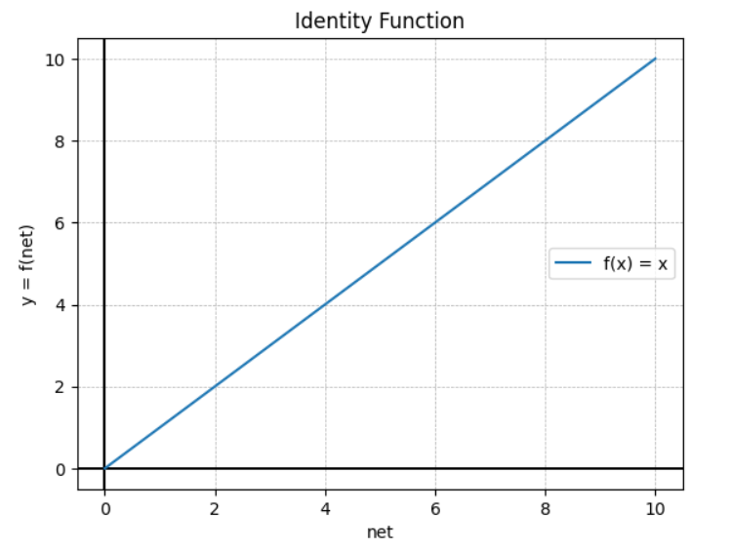

- Binary step function / Threshold function:
def binaryStep(values, threshold):
y = []
for x in values:
if x < threshold:
y.append(0)
elif x >= threshold:
y.append(1)
return y
x = np.arange(0, 5, 0.001)
t = 2
y = binaryStep(x, t)
plt.axvline(x=0, c="black")
plt.axhline(y=0, c="black")
plt.plot(x, y, label = "f(x) = 1 if x >= 2 \nf(x) = 0 if x < 2")
plt.grid(linestyle = '--', linewidth = 0.5)
plt.title("Binary Step Function\nThreshold = 2")
plt.xlabel("net")
plt.ylabel("y = f(net)")
plt.legend()
plt.show()

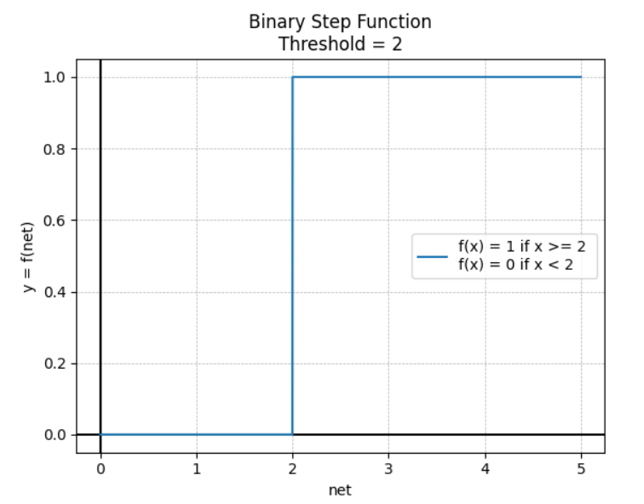

- Sigmoid function:
This function is defined as follows:
f(net) = $\frac{1}{1+ e^{-λx}}$
x = np.linspace(-10, 10, 100)
y = 1/(1 + np.exp(-2*x))
plt.axvline(x=0, c="black")
plt.axhline(y=0, c="black")
plt.plot(x, y, label = "f(x) = 1/(1 + e^(-2*x))")
plt.grid(linestyle = '--', linewidth = 0.5)
plt.title("Sigmoid Function")
plt.xlabel("net")
plt.ylabel("y = f(net)")
plt.legend()
plt.show()
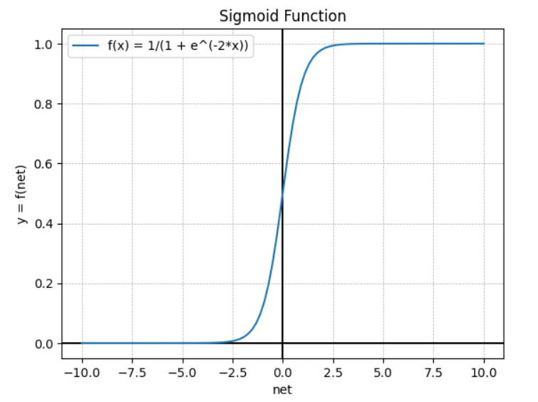

- Bipolar sigmoid function / Tangent function:
This function is defined as follows:
f(net) = $\frac{2}{1+ e^{-λx}}$– 1
x = np.linspace(-10, 10, 100)
y = 2 / (1 + np.exp(-0.5*x)) - 1
plt.axvline(x=0, c="black")
plt.axhline(y=0, c="black")
plt.plot(x, y, label = "f(x) = 2/(1 + e^(-2*x)) - 1")
plt.grid(linestyle = '--', linewidth = 0.5)
plt.title("Bipolar Sigmoid Function")
plt.xlabel("net")
plt.ylabel("y = f(net)")
plt.legend()
plt.show()
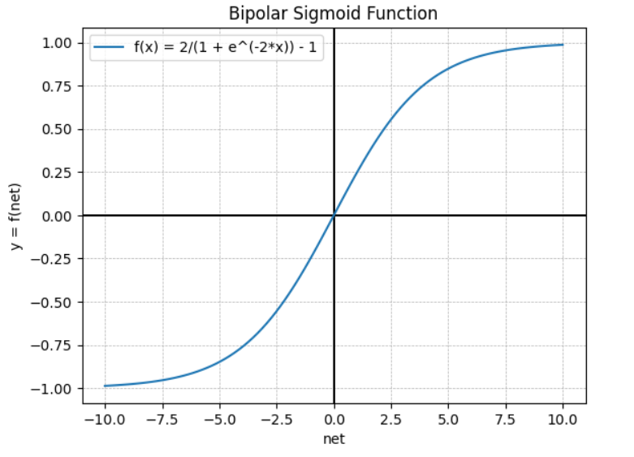

- Ramp function:
def ramp(values, threshold1, threshold2):
y = []
for x in values:
if x <= threshold1:
y.append(0)
elif threshold1 < x < threshold2:
y.append(x-threshold1)
elif x >= threshold2:
y.append(threshold2-threshold1)
return y
x = np.arange(0, 10, 0.001)
t1 = 3
t2 = 6
y = ramp(x, t1, t2)
plt.axvline(x=0, c="black")
plt.axhline(y=0, c="black")
plt.plot(x, y, label = "f(x) = 0 if x <= 3 \nf(x) = x-3 if 3 < x < 6 \nf(x) = 3 if x >= 6")
plt.grid(linestyle = '--', linewidth = 0.5)
plt.title("Ramp Function")
plt.xlabel("net")
plt.ylabel("y = f(net)")
plt.legend()
plt.show()
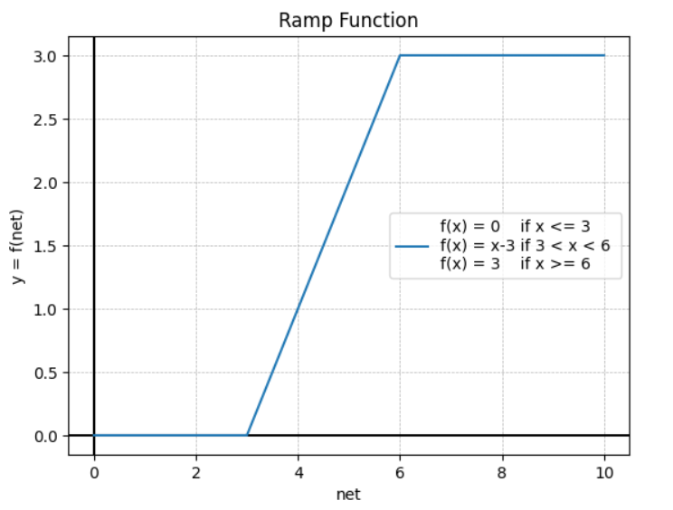
- ReLU function:
def relu(values):
y = []
for x in values:
if x <= 0:
y.append(0)
else:
y.append(x)
return y

x = np.linspace(-10, 10, 100)
y = relu(x)
plt.axvline(x=0, c="black")
plt.axhline(y=0, c="black")
plt.plot(x, y, label = "f(x) = 0 if x <= 0 \nf(x) = x if x > 0")
plt.grid(linestyle = '--', linewidth = 0.5)
plt.title("ReLU Function")
plt.xlabel("net")
plt.ylabel("y = f(net)")
plt.legend()
plt.show()
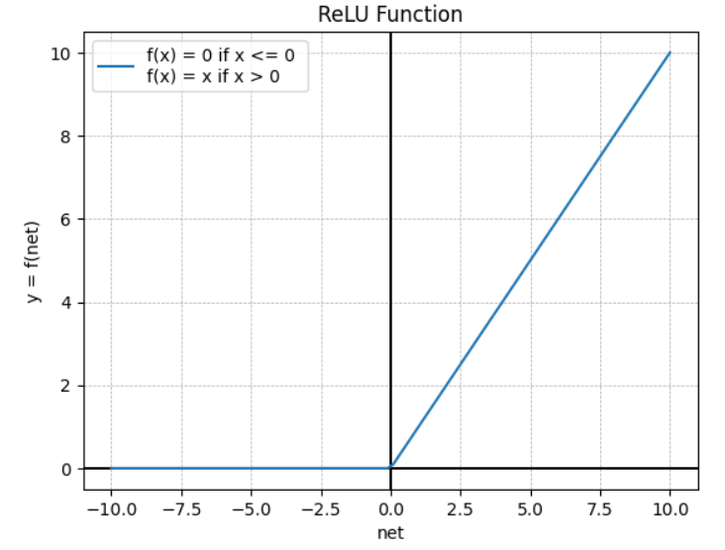
- Softmax function:
This function is defined as follows:
f(x) = $\frac{e^{x}}{\sum_{i=1}^{n}{e^{x_{i}}}}$
def softmax(values):
y = []
denominator = sum([np.exp(x) for x in values])
for x in values:
numerator = np.exp(x)
result = numerator / denominator
y.append(result)
return y
x = np.arange(0, 11, 1)
y = softmax(x)
plt.axvline(x=0, c="black")
plt.axhline(y=0, c="black")
plt.plot(x, y, label = "softmax")
plt.grid(linestyle = '--', linewidth = 0.5)
plt.title("SoftMax Function")
plt.xlabel("net")
plt.ylabel("y = f(net)")
plt.legend()
plt.show()
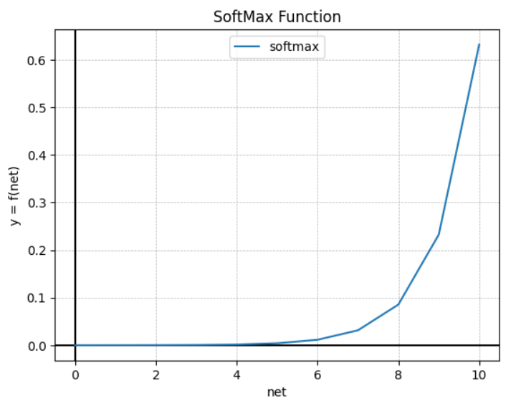

Conclusion:
Thus, we have successfully implemented 5 Activation Functions of Neural Network.

Post Lab Descriptive Questions:

- Explain the concept behind using Activation function.
The activation function decides whether a neuron should be activated or not by calculating the weighted sum and further adding bias to it. The purpose of the activation function is to introduce non-linearity into the output of a neuron.

- Explain the different properties of activation functions.
The properties of activation function are:
- Non- Linearity:
Introducing non-linearity into the network allows us to model a response variable that varies non-linearly with its explanatory variables.
Non-linear means that the output cannot be reproduced from a linear combination of the inputs. Without a non-linear activation function in the network, a NN, no matter how many layers it had, would behave just like a single-layer perceptron, because summing these layers would just give another linear function.
- Continuously differentiable:
This property is necessary for enabling gradient-based optimization methods.
The binary step activation function is not differentiable at 0, and it differentiates to 0 for all other values, so gradient-based methods can make no progress with it.
- Range:
When the range of the activation function is finite, gradient-based training methods tend to be more stable, because pattern presentations significantly affect only limited weights.
When the range is infinite, training is generally more efficient because pattern presentations significantly affect most of the weights. In the latter case, smaller learning rates are typically necessary.
- Monotonic:
When the activation function is monotonic, the error surface associated with a single-layer model is guaranteed to be convex.
- Approximates identity near the origin:
When activation functions have this property, the neural network will learn efficiently when its weights are initialized with small random values.
When the activation function does not approximate identity near the origin, special care must be used when initializing the weights.

Date: 16/10/2023 Signature of faculty in-charge

